

Saturday Sports Injury Clinic



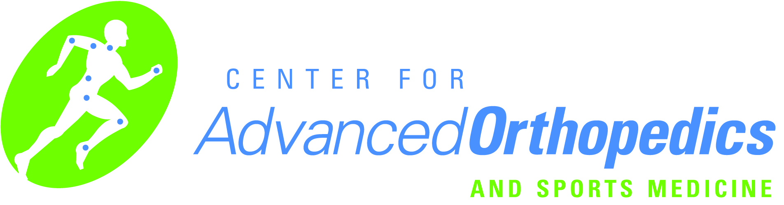

**Center for Advanced Orthopedics**

**3100 Cross Creek Pkwy #200 Dr. Matthew Prince**

**Auburn Hills MI 48326 Dr. Ryan Siwiec**

**248.377.8000 Board Certified Orthopedic Surgeons**

[**www.centerforao.com**](http://www.centerforao.com) **Fellowship Trained Sports Medicine**

**Find us on Facebook**

**\*\*\*No Appointment Needed\*\*\***

**8 - 11am Saturdays September 8th through October 27th**

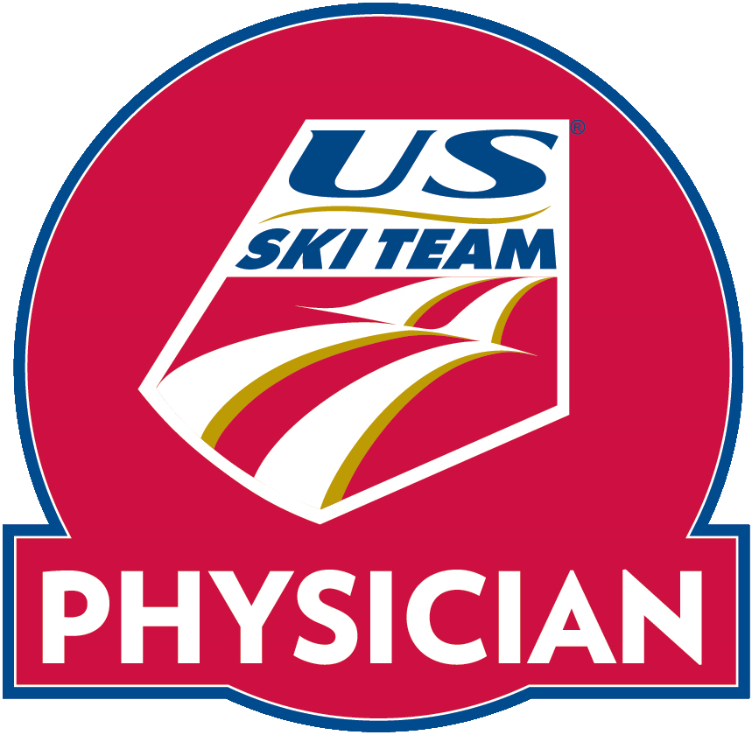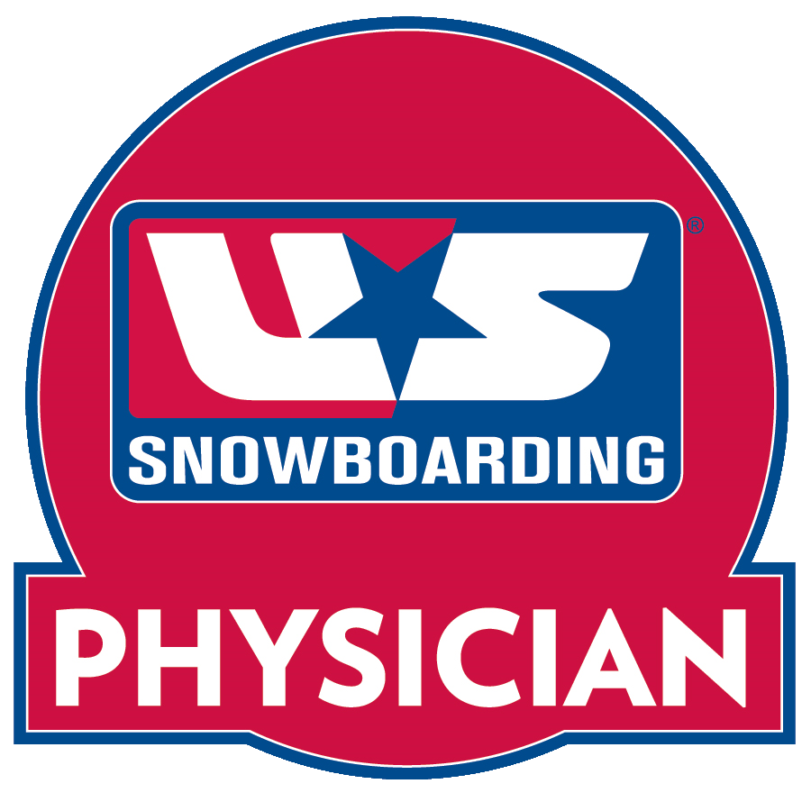

Get back in the game